OCCLUSAL VERTICAL DIMENSION ANALYZED BY DIGITAL PHOTOGRAPHY USING iOS SMARTPHONE CAMERA

Rani Purba¹, Ade Renita Putri², Nabilah Lendy³, Tyas Hestiningsih⁴, Arya Prasetya Beumaputra⁵

^{1,4,5}Department of Prostodonsia, Dentistry Program, Faculty of Medicine, Sriwijaya University, Palembang, Indonesia
^{2,3}Dentistry Program, Faculty of Medicine, Sriwijaya University, Palembang, Indonesia

ranipurba@fk.unsri.ac.id

Abstrak

Occlusion vertical dimension (OVD) measurement of digital photo analysis using iOS smartphone camera offers a practical alternative to using a DSLR (digital single-lens reflex) camera. The camera is equipped with iOS sensor shift technology and portrait mode, which offers automatic and flexible operation.. Objective: This study aimed to compare OVD results between direct measurement (Willis) and digital photo analysis using iOS smartphone camera.Methods: This study was an analytic observation with a cross-sectional approach. The total samples were 30 Sriwijaya University dental students, divided into 2 groups; group 1 direct measurement (Willis) and group 2 digital photo analysis (iOS smartphone camera). The OVD was measured from subnasion to menton in occlusion. The data were analyzed using the Paired T test. Results: The results showed no difference between the OVD of the Willis method and digital photo analysis (iOS smartphone camera) (p> 0.05). Conclusion: There was no difference the results OVD between direct measurement (Willis) and digital photo analysis using iOS smartphone camera.

Keywords: vertical dimension, digital photography, iOS smartphone

- Introduction

Occlusion vertical dimension (OVD) measurement in denture processing, which can be measured by several methods, such as indirect measurement method by digital photo analysis.¹ The digital technology using computer-aided design / manufacturing (CAD / CAM) combined with 3D facial digital photo scans has been used to record OVD in the current denture processing.²⁻³ Generally, digital photos are taken by a DSLR (digital single-lens reflex) camera which is equipped with a large device size, a lens and specific settings with complex photography technical operation.⁴⁻⁸ Smartphone cameras are considered more effective than DSLR, it provides easy access, automatic and flexible camera settings.⁵⁻⁶ Samosir et al. stated that there was no difference between smartphone and DSLR camera measurements of 3D model objects size, so smartphone camera can be used as an alternative to digital photo cameras.⁹⁻¹⁰ The iOS smartphone (iPhone operating system) is a commonly used smartphone developed by Apple. It offers a variety of advanced technologies and features, including OIS (Optical Image Stabilization), which uses shift sensor camera technology to reduce vibrations in the image capture process. This technology produces more stable and sharp images. The camera's portrait mode feature automatically blurs the background of the object.¹¹⁻¹³
This study aims to determine the difference in the measurement of OVD by direct measurement (Willis method) and digital photo analysis (iOS smartphones). Digital photography using iOS smartphones is expected to provide potential OVD results close to direct measurement.
- Method
This study was an observational analytic study with a cross sectional approach. The subject’s data of this research were 30 pre-clinical dentistry study program at Universitas Sriwijaya with the inclusion and exclusion criteria as below:¹⁴
  - Inclusion criteria
    - Male and female aged 18-25 years old.
    - Having complete permanent teeth up to the second molar.
    - Class 1 angle
  - Exclusion criteria
    - Open bite or deep bite.
    - Having orthodontic treatment.
    - Using denture
    - Having history of facial surgery
The minimum sample size (Champion) was is 30 people.¹⁵
This study was divided into 2 groups. The procedures for each group were as follows :
- Group I, direct measurement (Willis) as control (n=15) :
  - After passing ethical eligibility tests, the subject was instructed to sit up straight on a chair and look forward (the natural position for the head).¹
  - The two anatomical points were measured on the subject's face (the nose and chin base) were marked using a black marker (Figure 1).¹⁶

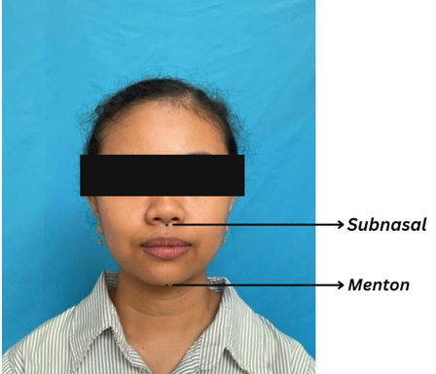
Figure 1. Both anatomical points were marked

- The subject was instructed to swallow so the teeth are in centric occlusion.
- OVD of direct measurements were measured the distance of the nose base (nasolabial angle) to the chin (menton) using a caliper. Measurements were recorded three times and calculated in millimeters.¹⁷

- Group II, indirect measurement of digital photo analysis using iOS smartphone camera (n=15) with the same subjects :
  - A blue cloth was used the photos backdground.
  - The subject was instructed to sit up straight and not lean forward. They were also told to look straight ahead in the mirror, which was 110 centimeters away.¹⁸⁻²⁰
  - The smartphone was set up on a tripod. The camera lens was lined up with the subject's subnasal point. The camera was 50 centimeters away from the subject. (Figure 2).^{21,22}

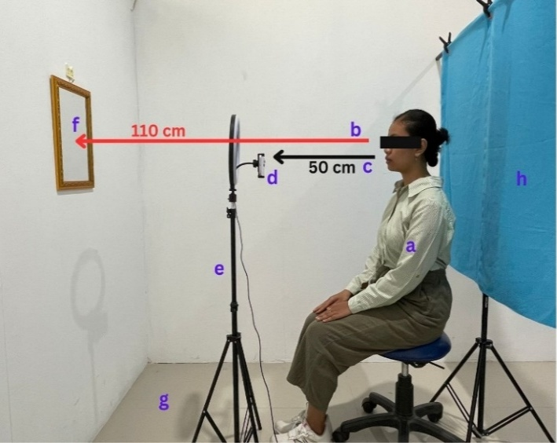
Figure 2. Digital photo taking position (a) subject position, (b) distance subject-mirror, (c) distance subject-smartphone camera, (d) smartphone, (e) ring light, (f) mirror, (g) tripod, (h) photo background

  - Before taking the photo, the portrait mode camera was set to natural light and the depth control (to set the focus and determine the depth of of image field) to f/16 (lens opening/aperture value) (Figure 3).^{13,23}

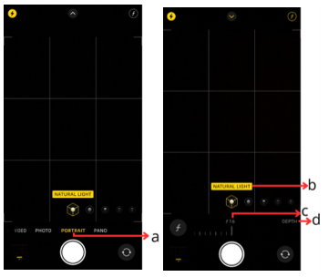
Figure 3. a. Portrait mode, b. natural light c. f/16, d. depth control
  - The subject was set in the center grid (a display of nine small squares on the camera) (Figure 4).²⁴
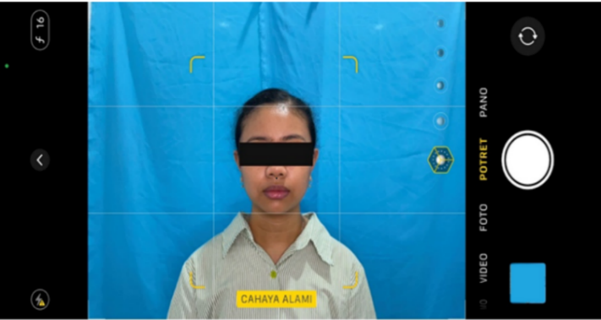
Figure 4. Subject position on the grid iOS smartphones

- The OVD mesurementment procedures were same as the group 1. ^{16,17,25}
- The digital photos were inputted to a laptop, calibrated by the FILEminimize Pictures application (image optimization application).^{26,27} They were get measurement results close to the direct method, a ratio of 1:6 was used, pixel ratio was 640x480.²⁷
- The photos were analyzed using bitmap-based software version 2023 (Adobe Photoshop CC 2023).^{28,29}
- The two anatomical points previously marked were connected on the photo using the "Pencil Tool" on the software. (Figure 10).
- The measurement results are recorded in millimeters.
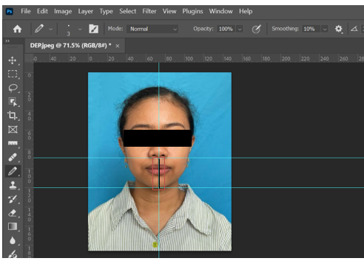

Figure 5. Both anatomical points was analyzed by bitmap software

Results
The distribution of research subjects were could be seen in table 1.
Table 1. Mean OVD results according to measurement method
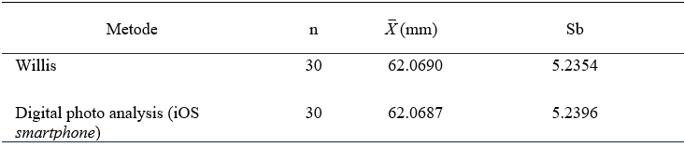
Data were analyzed with the normality test using the Shapiro-Wilk test and the results were normally distributed (p>0.05)

Table 2. Paired T test results on OVD size between measurement methods
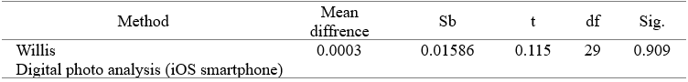
Based on Table 2, the results showed no difference between direct measurement method and digital photo analysis iOS smartphone (p>0.05).

- Discussion
The results showed that there was no difference in the OVD of direct and indirect method (digital photo analysis iOS smartphone). The photo results obtained from digital photo analysis digital iOS smartphone were influenced by several factors, such as the the smartphone camera distance and position to the subject, the type of smartphone, and photo background.^{21,24,30}
This research was carried out using a 50-centimeter distance between the camera and the subject, based on Bertazzo and others.²¹ Previous researchers had done some preliminary research comparing photo results using 30 and 50 centimeters. The results of using a 50 centimeter distance were closer to direct measurement. The photo will be distorted if the camera is too close to the subject. The object appears disproportionate. It is larger or smaller than the original size. If the camera is too far away, the photo will be less detailed.^{31.32}
The camera is positioned based on the rule of thirds, a method for arranging objects in a photo. Important elements are indicated by lines and the grid intersection. Aligning the object with the grid ensures that the photo is consistent and accurate.²⁴ The subject's face is centered in the grid for proportion. The camera stood on a tripod to prevent shaking when taking pictures.¹³ Smartphone cameras are considered more effective, easier to access, and have more flexible settings.^{5,6} The camera's portrait mode feature uses a setting called "depth control f/16" to focus and determine the depth of the image field.²³ Moussa et al. compared tooth model size accuracy with the iOS smartphone camera and found no difference with DSLR camera photos.⁶ DSLR cameras are the optimal choice for clinical photography, but their specialized settings, including aperture, exposure time, and ISO, can present challenges for dentists during operation.^{5,6} The iOS smartphone camera has photonic engine technology for better low-light photos. As a result, clearer images, finer details, and less noise are achieved.³⁷
The ideal background for medical photography is blue, it works for all skin tones. A white background may not provide enough contrast.³⁴ This research software was bitmap-based version 2023 (Adobe Photoshop CC 2023) used to analyze digital photos. This bitmap-based version 2023 (Adobe Photoshop CC 2023) research software analyzes digital photos. It is affordable and easy to use and measure certain points on the face in digital photos ⁶ Fachriani et al. found no significant difference between digital photo analysis and the Willis method for measuring freeway space distance.³³
iOS smartphone photo technology combined with facial scanning and CAD/CAM can create virtual patient models, reducing the risk of measurement errors.³⁵ Amezua et al. found virtual facebow accuracy close to direct facebow with 3-dimensional software on iOS smartphones made using CAD/CAM machinery.³⁶ Digital photos are convenient and fast. They facilitate data acquisition by internet media and processing or reviewing results before and after treatment. They can also serve as electronic medical records for future treatment rehabilitation.⁴

- Conclusion
There was no difference between the OVD result by direct measurement (Willis method) and digital photo analysis using an iOS smartphone camera.

Reference
- Gomes VL, Goncalves LC, Correia CLM, Lucas BL, Carvalho PM. Vertical Dimension of the Face Analyzed by Digital Photographs. European Journal of Esthetic Dentistry. 2008;3(4):362–70.
- Cruvinel AC, da Rocha SS. Fully Digital Workflow Protocol to Increasing Occlusion vertical dimension of Dentate Patients. J Dent Health Oral Disord Ther. 2022 Nov 21;13(4):92–6.
- Oancea L, Burlibasa M, Petre AE, Panaitescu E, Cristache CM. Predictive Model for Occlusal Vertical Dimension Determination and Digital Preservation with Three-Dimensional Facial Scanning. Applied Sciences (Switzerland). 2020 Nov 1;10(21):1–15
- Wirahadikusumah A, Koesmaningati H, Fardaniah S. Digital Photo Analysis as a Predictor of Physiological Vertical Dimension. Journal of Dentistry Indonesia. 2011;18(2):38–44.
- Shahrul AI, Shukor N, Norman NH. Technique for Orthodontic Clinical Photographs Using a Smartphone. Int J Dent. 2022 Jan;2022:1–5.
- Moussa C, Hardan L, Kassis C, Bourgi R, Devoto W, Jorquera G, et al. Accuracy of Dental Photography: Professional vs Smartphone’s Camera. Biomed Res Int. 2021 Dec;2021:1–7.
- Riyadi T. Sinematografi dengan Kamera DSLR. Humaniora [Internet]. 2014 Oct;5(2):919–29. Available from: http://www.gizmag.com/entry-mid-range-dslr-buyers-guide/25459/
- Lorensius A, Arifah Prastiningtyas D, Eka Purwiantono F. Sistem Pendukung
- Keputusan Pemilihan Kamera DSLR Dengan Metode Promethee. J-INTECH. 2019;7(2):126–34.
- Sahala Samosir F, Riyadi S. Comparison of Smartphone and DSLR Use in Photogrammetry. 2020.
- Deli, Mayang Kirana Putri Sofiandi I. Studi Komparasi Hasil Foto Dan Video Antara Mirrorless Camera Dan Iphone. Conference on Management, Business, Innovation, Education and Social Science [Internet]. 2021;1(1):903–11. Available from: https://journal.uib.ac.id/index.php/combines
- Singh EN. Comparison Between Android and IOS. Pramana Research Journal [Internet]. 2018;8(8):524–6. Available from: http://www.ijtrd.com/papers/IJTRD8584.pdf
- Tjin E, Mulyadi E. Kamus Fotografi. Jakarta: PT Elex Media Komputindo ; 2014.
- Mosier M, Barmak B, Gómez-Polo M, Zandinejad A, Revilla-León M. Digital and Analog Vertical Dimension Measurements: A Clinical Observational Study. Int J Prosthodont. 2021 Jul;34(4):419–27.
- Pasolong H. Metode Penelitian Administrasi Publik. 4th ed. Bandung: Alfabeta; 2020.
- Nallaswamy D, Ramalingam K, Bhat V. Textbook of Prosthodontics. 1st ed. New Delhi: Jaypee Brothers Medical Publishers; 2003.
- Dipoyono HM, Susanto GT, Indrastuti M. Vertical Dimension of Rest (VDR) Analysis Using Photography Application. Indian J Public Health Res Dev. 2020 Mar;11(03):2413–8.
- Rao SJ, Valapula S. Soft Tissue Treatment Goals for Orthodontic Patients- A Photogrammetric Analysis of Facial Profile for Soft Tissue Norms and Gender Variations in Young Adults, Hyderabad, India. Journal of Clinical and Diagnostic Research. 2022;16(5):10–5.
- Meneghini F. Clinical Facial Analysis. Schroder G, editor. New York: Springer; 2005.
- Nair AG, Santhanam A. Clinical Photography for Periorbital and Facial Aesthetic Practice. J Cutan Aesthet Surg. 2016 Apr 1;9(2):
- Bertazzo TL, D’Ornellas MC. Protocol for Capturing 3D Facial Meshes for Rhinoseptoplasty Planning. Braz J Otorhinolaryngol. 2023 Sep 1;89(5):1–10.
- D’Ettore G, dkk. A Comparison Between Stereophotogrammetry and Smartphone Stuctured Light Technology for Three-Dimensional Face Scanning. Angle Orthodontist. 2022; 92(3): 358-363.
- Ilenghoven D, Nsir NAM, Johar SFNM, Yussof SJM. Effectiveness of Smart Phone Use for Clinical Photograph. | Journal of Asia Pacific Aesthetic Sciences [Internet]. 2021;1(1). Available from: www.japa-edu.org
- Ahmad R. Essentials of Dental Photography. 2020. 1st ed., Oxford: Willey
- Makzoumé JE. A Procedure for Directly Measuring the Physiologic Rest Position and Occlusal Vertical Dimension. Journal of Prosthetic Dentistry. 2017 May 1;117(5):697–8.
- Shariati MM, Shoeibi N. Image Calibration in Choroidal Vascularity Index Measurement. Int J Retina Vitreous. 2023 Dec 1;9(1):1–3.
- Huda A, Ardi Noper. Teknik Multimedia dan Animasi. 1st ed. Thahar HE, editor. Padang: UNP Press; 2021.
- Enterprise J. Belajar Sendiri Adobe Photoshop CC 2015-2019. 1st ed. Jakarta: PT Elex Media Komputindo; 2019.
- Setiadi T. Desain Grafis (Kreasi Efek Photoshop CC). Widiastuti S, Dianta IA, editors. Semarang: Yayasan Prima Agus Teknik; 2020.
- Khavkin J, Ellis DAF. Standardized Photography for Skin Surface. Facial Plast Surg Clin North Am. 2011 May;19(2):241–6.
- Derakhshan A, dkk. Quantifying Facial Distortion in Modern Digital Photography. The Laryngoscope. 2024; 134: 1234-1238.
- Olver A, Gurlyn H, dan Liscio E. The Effects of Camera Resolution and Distance on Suspect Height Analysis Using PhotoModeler. 2020. https://doi.org/10.1016/j.forsciint.2020.110601
- DXOMARK. Professional Quality Control Laboratory for Digital Camera Systems and Smartphone Cameras. Diakses pada 5 September 2024 melalui https://www.dxomark.com/smartphones-vs-cameras-closing-the-gap-on-image-quality
- Fachriani, dkk. Comparison of Freeway Space Distance of Willis Method with Digital Photo Analysis Method in Banjar Tribe. Dentino Jurnal Kedokteran Gigi. 2024; IX(2): 133-138.
- Hassan B, Greven M, Wismeijer D. Integrating 3D facial scanning in a digital workflow to CAD-CAM design and fabricate complete dentures for immediate total mouth rehabilitation. J Adv Prosthodont [Internet]. 2017;9(5):1–6. Available from: https://doi.org/10.4047/jap.2017.
- Amezua X, dkk. Analysis of the impact of the facial scanning method on the precision of a virtual facebow record technique: An in vivo study. The journal of prosthetic dentistry. 2023; 13(3): 382-391.

