Rapidly Progressive Meningeal Melanomatosis Presenting During Pregnancy: A Rare and Aggressive Entity
Yunni Diansari¹, Rizka Aprillia Syahputri^{1*}, Aspitriani², Hanna Marsinta Uli³

¹Neurology Department of Dr Mohammad Hoesin Hospital Palembang/ Medical Faculty of Universitas Sriwijaya
²Pathology Anatomy Department of Medical Faculty of Universitas Sriwijaya
³Radiology Department of Medical Faculty of Universitas Sriwijaya

*Corresponding author: rizka.aprilia08@gmail.com

Abstract
Background:
Meningeal melanomatosis is an extremely rare and aggressive melanocytic neoplasm of the central nervous system characterized by diffuse leptomeningeal involvement. Its occurrence during pregnancy is exceptionally uncommon and presents significant diagnostic and therapeutic challenges.
Case Presentation:
A 39-year-old woman at 15 weeks of gestation presented with progressive headache and left-sided weakness. Brain MRI revealed a right frontal extra-axial mass with surrounding edema and subfalcine herniation. Surgical resection was performed due to neurological deterioration. Histopathological and immunohistochemical analysis confirmed malignant melanoma (S100-positive, HMB-45-positive, high Ki-67 index). Postoperative MRI demonstrated residual extra-axial mass suspicious for meningeal melanomatosis. Focal radiotherapy (20 Gy) was administered. The patient subsequently experienced spontaneous preterm delivery. Four months later, bilateral breast metastases were identified. Progressive neurological decline occurred, and the patient died eight months after initial diagnosis.
Conclusion:
Meningeal melanomatosis during pregnancy represents a rare and highly aggressive condition with poor prognosis despite multimodal treatment.
Keywords: Meningeal melanomatosis; Pregnancy; melanoma

- INTRODUCTION

Meningeal melanomatosis is a rare malignant proliferation of leptomeningeal melanocytes characterized by diffuse infiltration of the meninges. It accounts for a minute proportion of primary intracranial tumors and is associated with rapid clinical deterioration and poor survival. Although melanoma in pregnancy has been discussed in the literature, particularly regarding hormonal and immunological influences, there are currently no specific studies addressing meningeal melanomatosis occurring during pregnancy. The absence of dedicated evidence complicates clinical decision-making, particularly when balancing maternal neurological survival and fetal safety.

- CASE REPORT

A 39-year-old woman at 15 weeks of gestation was admitted in July 2025 with progressive headache accompanied by worsening left-sided weakness. She had a prior history of chronic headaches and seizure disorder. On admission, she was conscious with a Karnofsky Performance Status (KPS) score of 40 and a Numeric Pain Rating Scale (NPRS) score of 6–7. Neurological examination revealed facial and hypoglossal nerve palsy, left hemiparesis (muscle strength 3/5 in the upper extremity and 0/5 in the lower extremity), and left-sided hemihypesthesia. Dermatologic examination demonstrated multiple irregular hyperpigmented maculopatches over the temporal scalp region.

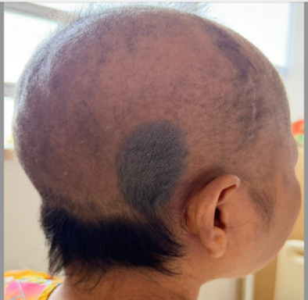
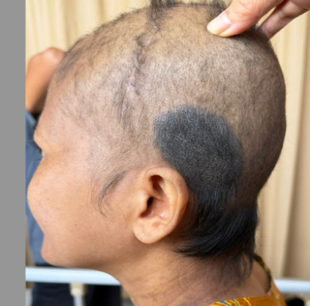

Figure 1. Multiple hyperpigmented macular patches with irregular, lenticular to nummular shapes, discretely distributed over the temporal region.

Initial non-contrast brain magnetic resonance imaging (MRI) performed on June 27, 2025 revealed a suspicious right frontal extra-axial mass associated with marked cerebral edema and subfalcine herniation. Obstetric evaluation confirmed a viable singleton pregnancy at 15 weeks of gestation. The patient was started on dexamethasone for cerebral edema and lamotrigine for seizure control. During hospitalization, her level of consciousness deteriorated, prompting multidisciplinary tumor board discussion and subsequent surgical tumor resection.

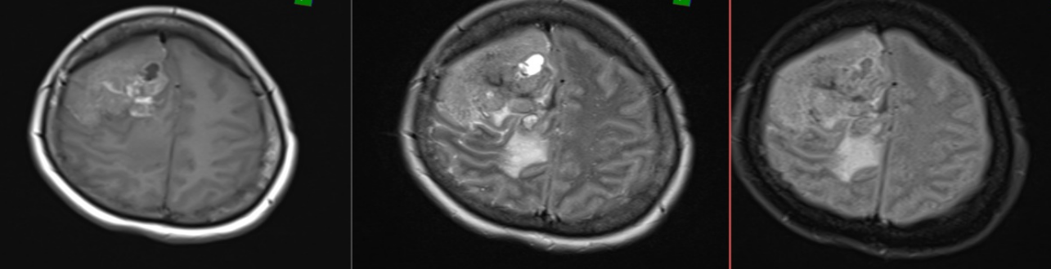

Figure 3. Preoperative contrast-enhanced brain MRI demonstrates a suspicious extra-axial mass in the right frontal region causing subfalcine herniation and cerebral edema.

Histopathological examination revealed malignant melanoma, supported by immunohistochemical findings showing strong positivity for S100 and HMB-45, along with a high Ki-67 proliferation index, indicating aggressive tumor behavior. Postoperative MRI performed on August 14, 2025 demonstrated a residual extra-axial mass measuring 6.1 × 3.3 × 3.3 cm attached to the right frontal meninges, with a central postoperative craniectomy defect. Significant mass effect persisted, including effacement of cortical sulci, narrowing of the Sylvian fissure, midline shift to the left, and compression of the lateral ventricles and third ventricle, raising suspicion for meningeal melanomatosis.

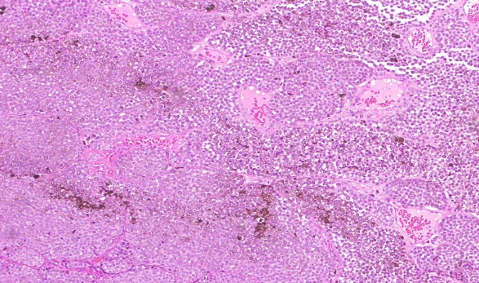
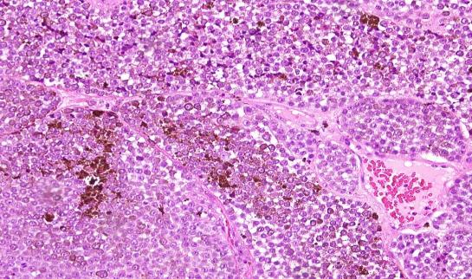

Figure 4. Histopathological examination revealed malignant melanoma, supported by immunohistochemical findings showing strong positivity for S100 and HMB-45, along with a high Ki-67 proliferation index, indicating aggressive tumor behavior

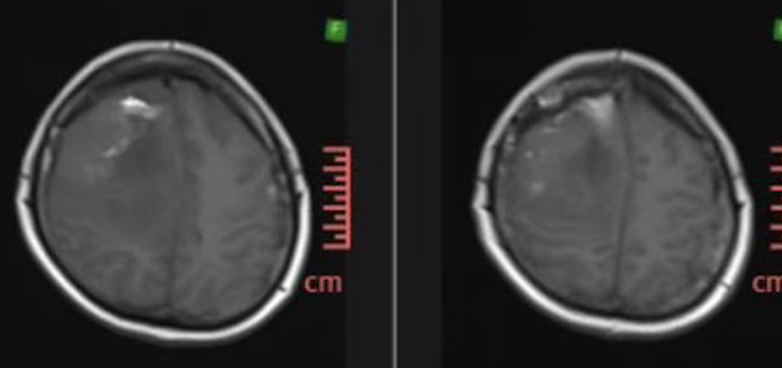
Figure 3. Postoperative contrast-enhanced brain MRI demonstrates a suspicious extra-axial mass consistent with meningeal melanomatosis, measuring 6.1 × 3.3 × 3.3 cm, attached to the meninges in the right frontal region. A central postoperative defect is noted within the mass. Surrounding mass effect involves the frontoparietal lobes, resulting in effacement of the cortical sulci and Sylvian fissure, leftward midline shift, and compression of the bilateral lateral ventricles and the third ventricle.

One month after surgery, focal radiotherapy with a total dose of 20 Gy was administered. Two months postoperatively, the patient experienced spontaneous preterm delivery. In the postpartum period, her general condition was temporarily stable with partial improvement in neurological deficits and adequate seizure control. Follow-up MRI after radiotherapy demonstrated no significant change in tumor size. Systemic therapy was not initiated due to financial constraints.
Four months after tumor resection, bilateral breast masses were detected. Core needle biopsy revealed a malignant round cell tumor consistent with metastatic melanoma. Subsequently, the patient developed new neurological deficits in the form of bilateral ophthalmoplegia. Contrast-enhanced brain MRI revealed new intracranial lesions consistent with disease progression. Despite supportive management, her condition continued to deteriorate, and she died approximately eight months after the initial diagnosis due to uncontrolled infection.

- DISCUSSION
Meningeal melanomatosis represents an exceptionally uncommon and highly aggressive malignant proliferation of leptomeningeal melanocytes.¹ It occupies the most malignant end of the spectrum of central nervous system (CNS) melanocytic tumors, which ranges from benign melanocytoma to overt malignant melanoma.² Because only a limited number of cases have been documented globally, its precise incidence remains undefined.¹ Nevertheless, it constitutes only a negligible proportion of intracranial neoplasms and is typically associated with rapid neurological deterioration and poor survival outcomes.³
From a radiological perspective, melanocytic tumors frequently demonstrate intrinsic hyperintensity on T1-weighted MRI sequences, attributed to the paramagnetic properties of melanin. However, imaging characteristics may vary depending on melanin content, hemorrhage, or necrosis. In the present case, the identification of a large right frontal extra-axial mass with extensive cerebral edema, subfalcine herniation, and persistent postoperative residual lesion suggested aggressive leptomeningeal involvement. The sustained mass effect and early disease progression following surgical resection further reflected the malignant biological behavior characteristic of meningeal melanomatosis. ^{4,5,6}
Definitive diagnosis relies on histopathological and immunohistochemical evaluation. Strong expression of S100 and HMB-45, together with an elevated Ki-67 proliferation index in this patient, confirmed malignant melanoma with high proliferative activity.^{7,8} The markedly increased Ki-67 index likely correlates with the aggressive clinical course observed, including rapid intracranial progression and early systemic dissemination.⁹ Although breast metastasis from melanoma is relatively rare, it has been described in advanced-stage disease and generally signifies widespread hematogenous spread.¹⁰
The coexistence of pregnancy adds substantial biological and clinical complexity. Pregnancy is characterized by physiological immunotolerance, involving a shift toward humoral immunity and relative suppression of certain cell-mediated immune responses, which theoretically may facilitate tumor progression.^{11,12} Additionally, hormonal fluctuations—particularly increased estrogen and progesterone levels—have been hypothesized to influence melanoma biology, although current evidence remains inconclusive and, at times, conflicting.^{13,14} While cutaneous melanoma during pregnancy has been discussed in the literature, there are no specific studies addressing meningeal melanomatosis in pregnant patients. Consequently, its pathophysiological behavior and prognostic implications within the gestational context remain poorly understood.
The management of meningeal melanomatosis during pregnancy presents significant therapeutic and ethical challenges.¹⁵ Surgical intervention is often required to alleviate mass effect and prevent life-threatening herniation, as was necessary in this case.¹⁶ Radiotherapy may be considered depending on gestational age and estimated fetal radiation exposure; however, its benefits must be weighed against potential risks.¹⁷ Systemic therapies, including immune checkpoint inhibitors such as anti–PD-1 or anti–CTLA-4 agents, lack robust safety data in pregnancy, limiting their use. In this case, systemic treatment was further constrained by financial limitations.^{18,19} Even in non-pregnant patients, the prognosis of meningeal melanomatosis remains dismal, with reported median survival frequently less than six months despite multimodal management.^{20,21}
The rapid clinical progression observed in this patient—marked by persistent residual tumor, early distant metastasis, development of new intracranial lesions, and death within eight months of diagnosis—highlights the aggressive biological nature of diffuse leptomeningeal melanoma. The unfavorable outcome likely reflects both the intrinsic malignancy of the disease and the therapeutic limitations imposed by pregnancy and resource constraints.²²
Overall, this case underscores a significant gap in current knowledge regarding the interaction between pregnancy and diffuse leptomeningeal melanoma. Additional case documentation and further research are needed to better characterize its clinical behavior, refine therapeutic strategies, and improve prognostic understanding in this rare and challenging clinical entity.

- CONCLUSION
Meningeal melanomatosis is a rare and highly aggressive malignancy with poor prognosis. This case highlights the added complexity of pregnancy, which limits therapeutic options and complicates clinical decision-making. The rapid progression observed underscores the need for multidisciplinary management and further research to guide optimal treatment in this rare condition.

REFERENCE

- Garbacz, T., Osuchowski, M., & Bartosik-Psujek, H. (2019). Primary diffuse meningeal melanomatosis - a rare form of meningeal melanoma: case report. BMC neurology, 19(1), 271. https://doi.org/10.1186/s12883-019-1460-x
- Pellerino, A., Verdijk, R. M., Nichelli, L., Andratschke, N. H., Idbaih, A., & Goldbrunner, R. (2024). Primary Meningeal Melanocytic Tumors of the Central Nervous System: A Review from the Ultra-Rare Brain Tumors Task Force of the European Network for Rare Cancers (EURACAN). Cancers, 16(14), 2508. https://doi.org/10.3390/cancers16142508.
- Trinh V, Medina-Flores R, Taylor CL, Yonas H, Chohan MO. Primary melanocytic tumors of the central nervous system: Report of two cases and review of literature. Surg Neurol Int 13-Oct-2014;5:147. Available from: https://surgicalneurologyint.com/surgicalint-articles/primary-melanocytic-tumors-of-the-central-nervous-system-report-of-two-cases-and-review-of-literature/
- Varela-Poblete, J., Vidal-Tellez, A., Cruz-Quiroga, J. P., Montoya-Salvadores, F., & Medina-Escobar, J. (2022). Melanocytic lesions of the central nervous system: a case series. Arquivos de neuro-psiquiatria, 80(2), 153–160. https://doi.org/10.1590/0004-282X-ANP-2021-0082
- Varela-Poblete, J., Vidal-Tellez, A., Cruz-Quiroga, J. P., Montoya-Salvadores, F., & Medina-Escobar, J. (2022). Melanocytic lesions of the central nervous system: a case series. Arquivos de neuro-psiquiatria, 80(2), 153–160. https://doi.org/10.1590/0004-282X-ANP-2021-0082
- Pellerino, A., Verdijk, R. M., Nichelli, L., Andratschke, N. H., Idbaih, A., & Goldbrunner, R. (2024). Primary Meningeal Melanocytic Tumors of the Central Nervous System: A Review from the Ultra-Rare Brain Tumors Task Force of the European Network for Rare Cancers (EURACAN). Cancers, 16(14), Article 2508. https://doi.org/10.3390/cancers16142508
- Sun, J., Wang, C., Shu, Q., Liu, J., & Mao, G. (2015). A case report on intermediate-grade malignant meningeal melanocytoma with elevated cell proliferation index. International journal of clinical and experimental pathology, 8(9), 11698–11703.
- Lee, J. K., Rho, Y. J., Jeong, D. M., Rhim, S. C., & Kim, S. J. (2017). Diagnostic Clue of Meningeal Melanocytoma: Case Report and Review of Literature. Yonsei medical journal, 58(2), 467–470. https://doi.org/10.3349/ymj.2017.58.2.467
- Nakase, K., Matsuda, R., Okamoto, T., Nakagawa, I., Takeda, M., Sakata, K., & Nakase, H. (2023). Malignant Transformation and Leptomeningeal Melanomatosis in a Primary Meningeal Melanocytoma: A Case Report and Review of Literature. NMC case report journal, 10, 315–320. https://doi.org/10.2176/jns-nmc.2023-0109
- Mastoraki A, Gkiala A, Theodoroleas G, Mouchtouri E, Strimpakos A, Papagiannopoulou D, Schizas D (2022) Metastatic malignant melanoma of the breast: report of a case and review of the literature. Folia Medica 64(2): 354-358. https://doi.org/10.3897/folmed.64.e62755
- Pelczar, P., Kosteczko, P., Wieczorek, E., Kwieciński, M., Kozłowska, A., & Gil-Kulik, P. (2024). Melanoma in Pregnancy-Diagnosis, Treatment, and Consequences for Fetal Development and the Maintenance of Pregnancy. Cancers, 16(12), 2173. https://doi.org/10.3390/cancers16122173
- Zelin, E., Conforti, C., Giuffrida, R., Deinlein, T., di Meo, N., & Zalaudek, I. (2020). Melanoma in pregnancy: certainties unborn. Melanoma management, 7(3), MMT48. https://doi.org/10.2217/mmt-2020-0007
- Sumitomo, C., Iwata, Y., Sakai, Y., Tsukamoto, T., & Sugiura, K. (2023). Possible Association Between Melanoma Arising from Congenital Naevus and Oestrogen or Progesterone Receptor Expression: Clinicopathological Analysis. Acta dermato-venereologica, 103, adv00887. https://doi.org/10.2340/actadv.v103.5206
- Ramaraj, P. (2021). A Review of Progesterone Effects on Human Melanoma Cell Growth In-Vitro. In Global Women’s Health. IntechOpen. https://doi.org/10.5772/intechopen.101239
- Pelczar, P., Kosteczko, P., Wieczorek, E., Kwieciński, M., Kozłowska, A., & Gil-Kulik, P. (2024). Melanoma in Pregnancy-Diagnosis, Treatment, and Consequences for Fetal Development and the Maintenance of Pregnancy. Cancers, 16(12), 2173. https://doi.org/10.3390/cancers16122173
- Ricchizzi, S., Gallus, M., Stummer, W., & Holling, M. (2022). How Should We Treat Meningeal Melanocytoma? A Retrospective Analysis of Potential Treatment Strategies. Cancers, 14(23), 5851. https://doi.org/10.3390/cancers14235851
- Akter, S., Sharmin, T., Ikram, S., Parvine, E., Akhter, R., Begum, A., & Abedin, E. S. (2025). Assessing the Risks of Prenatal Radiation: Effects on Pregnancy and Neonatal Development. Journal of pharmacy & bioallied sciences, 17(Suppl 3), S2434–S2438. https://doi.org/10.4103/jpbs.jpbs_1675_24
- Hassel, J. C., Livingstone, E., Allam, J. P., Behre, H. M., Bojunga, J., Klein, H. H., Landsberg, J., Nawroth, F., Schüring, A., Susok, L., Thoms, K. M., Kiesel, L., & Berking, C. (2021). Fertility preservation and management of pregnancy in melanoma patients requiring systemic therapy. ESMO open, 6(5), 100248. https://doi.org/10.1016/j.esmoop.2021.100248
- Schneider C, Pozsgai M, Németh C, Battyáni Z, Lengyel Z. A Healthy Pregnancy During Treatment of Metastatic Melanoma with Immune Checkpoint Inhibitors: A Case Report. J Clin Med. 2025 Dec 4;14(23):8591. doi: 10.3390/jcm14238591. PMID: 41375894; PMCID: PMC12692992.
- Chorti E, Kebir S, Ahmed MS, Keyvani K, Umutlu L, Kanaki T, Zaremba A, Reinboldt-Jockenhoefer F, Knispel S, Gratsias E, Roesch A, Ugurel S, Scheffler B, Schadendorf D, Livingstone E, Meier F, Glas M, Zimmer L. Leptomeningeal disease from melanoma-Poor prognosis despite new therapeutic modalities. Eur J Cancer. 2021 May;148:395-404. doi: 10.1016/j.ejca.2021.02.016. Epub 2021 Mar 28. PMID: 33789203.
- Berzero, G., Diamanti, L., Di Stefano, A. L., Bini, P., Franciotta, D., Imarisio, I., Pedrazzoli, P., Magrassi, L., Morbini, P., Farina, L. M., Bastianello, S., Ceroni, M., & Marchioni, E. (2015). Meningeal melanomatosis: a challenge for timely diagnosis. BioMed research international, 2015, 948497. https://doi.org/10.1155/2015/948497
- Khaled, M. L., Tarhini, A. A., Forsyth, P. A., Smalley, I., & Piña, Y. (2023). Leptomeningeal Disease (LMD) in Patients with Melanoma Metastases. Cancers, 15(6), 1884. https://doi.org/10.3390/cancers15061884

